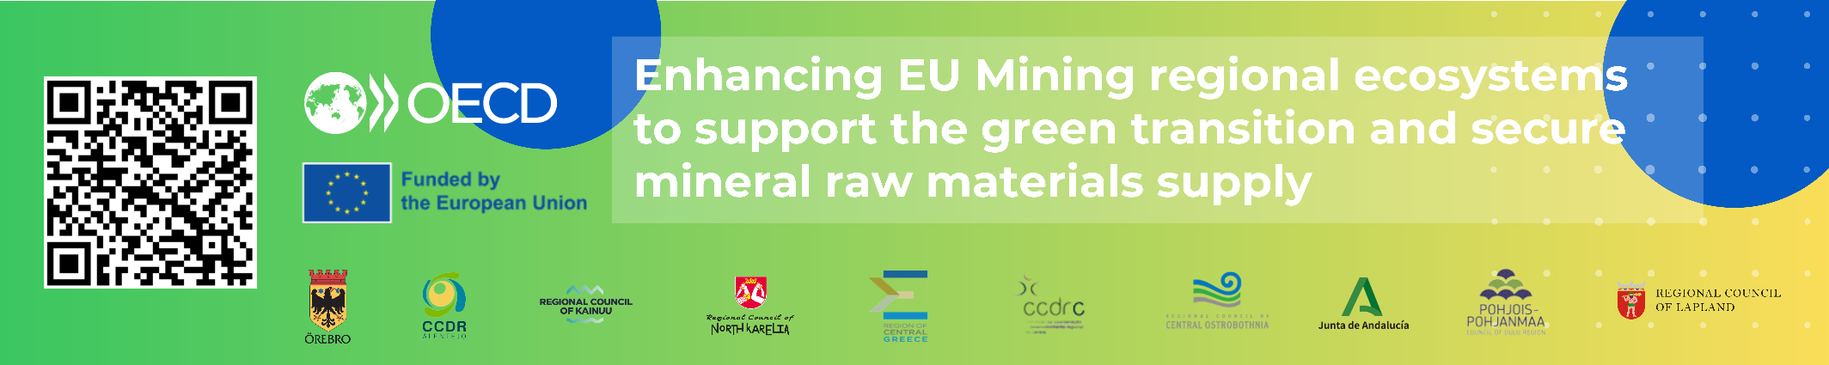

Inter-regional meeting: Takeaways from ten regional visits
23-24 May 2024, Chalkida, Evia, Region of Central Greece

On 23-24 May 2024 in Chalkia, Central Greece, the OECD, in collaboration with DG REFORM, presented the main takeaways from the regional visits for the project “Enhancing EU Mining Regional Ecosystems to Support the Green Transition and Secure Mineral Raw Materials Supply.”

The meeting was attended by representatives from the ten beneficiary regions: Lapland, North Karelia, Oulu, Kainuu, and Central Ostrobothnia (Finland), Region of Central Greece (Greece), Centro Portugal and Alentejo (Portugal), Andalusia (Spain), and Örebro (Sweden). 30 participants attended the meeting in-person, including representatives from the private sector and local governments in Central Greece, and a further 25 people joined online. The event also included a visit to the Mytilineos processing plant, the first producer of Bauxite and Alumina in EU.
Agenda available here

The event presented the main findings of the ten field visits carried out during the last 8 months across all regions. The common regional priorities highlighted through these field visits include:
- Mining governance and community engagement
- Environmental considerations
- Skills and employment
- Innovation and circularity
- Infrastructure.
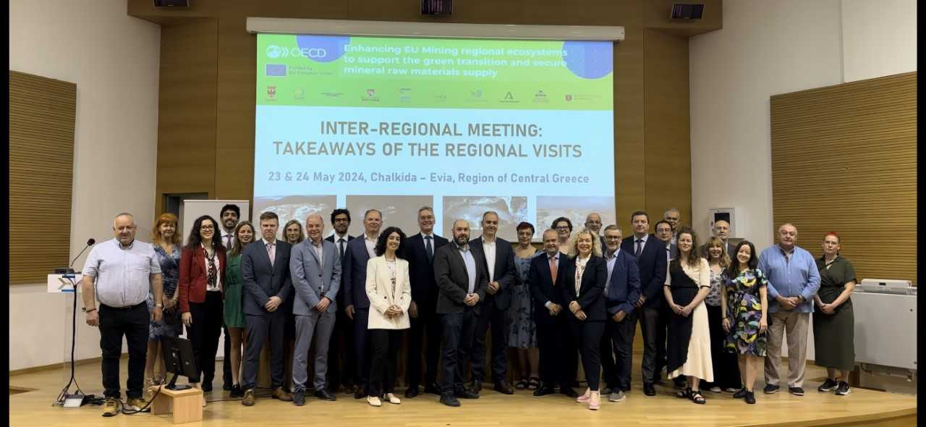
Representatives from the European Commission also intervened by sharing the strategic relevance of this multi-country Technical Support Instrument (TSI) project to advance strategic mineral supply goals in the EU and help build synergies across Member States.

Opening remarks
Official welcomes to Chalkida were provided by:
- George Kelaiditis, Deputy Regional Governor, Prefecture of Evia, Greece
- Konstantinos Galanis, Deputy Regional Governor for Development and Entrepreneurship, Greece
- Roula G. Kechri, Governor’s Advisor, Region of Central Greece

Central Greece representatives highlighted how the region, a historic leading producer of bauxite and aluminium in Europe, has leveraged its mining endowments to develop the regional industrial base, boost income and support community and transport infrastructure and the importance of this project in improving the existing mining ecosystem.

Other welcoming remarks provided by Kaspar Richter, The Head of Unit of the Sustainable Growth & Business Environment of DG REFORM, European Commission and Mika Riipi, Governor of Lapland, Finland highlighted:

- The mining industry's importance to the EU's goals for self-sufficient raw mineral supply and green technology production, amid global disruptions.
- The crucial role of regional governments in implementing EU legislation such as the EU Green Deal and EU Critical Minerals Act for long-term resilience.
- The TSI project's role in enhancing sustainable mineral supply policies at regional and national levels.
Preliminary findings from the OECD visits to ten beneficiary regions: good practices and policy priorities
Andres Sanabria and Fernando Riaza, OECD
- 10 field visits to beneficiary regions included:
  - Interviews to 450+ stakeholders across 26 municipalities,
  - Visits to 12 mines and 10+ educational institutions.
- Global Outlook of Critical Minerals from the International Energy Agency (IEA):
  - Maintained forecast of higher demand for critical minerals in the next 10 years, amid short-term price shocks in minerals due to greater supply from Asian markets.
- Preliminary recommended policy actions to enhance regional mining ecosystems:
  - Strengthening mining governance and company-community partnerships, with a focus on environmental considerations and monitoring.
  - More efficient permitting process with greater institutional coordination/capacity, guidelines and standardisation.
  - Innovation to improve involvement of local businesses and increased incentives for circularity and sustainable mining.
  - Better skill matching and increasing attractiveness of regions to workers.
  - Forward-looking green energy and transport infrastructure.
- Announced the upcoming 2024 OECD Conference of Mining Regions and Cities in Greater Sudbury, Canada, 8-11 October 2024.
Presentation available here

Madalina Ivanica - Deputy Head of Unit at DG GROW - Updates on CRM Act:
- Discussed the role of regions in implementing the EU Critical Raw Materials Act through support for strategic projects, communication and stakeholder engagement around mining, collaboration with various government levels and municipalities, and prioritising research and innovation related to mining.

Reactions from regions: initial learnings and common actions from field visits

1st Panel:

- Manuel Vazquez and Jesus Portillo, General Directorate of Mines, Government of Andalusia
- Luis Martins, President for Associação Cluster Portugal Mineral Resources, representing Alentejo region (in-person)
- Rosa Onofre, Director of Territorial Planning Unit, CCDR Alentejo (virtual)
- Jyrki Kaiponen, Governor, Central Ostrobothnia
- Roula G. Kechri, Governor’s Advisor, Region of Central Greece
- Markus Hirvonen, Governor, North Karelia

Main messages:
- Communication and transparency around mining projects is a regional priority to ensure mining projects leave a positive legacy locally and are undertaken with community support.
- Government agreements with mining companies for new projects can be an opportunity to address environmental liabilities and enhance social acceptability.
- Increasing innovation through local SMEs and entrepreneurs is relevant to advance sustainable mining practices and ensure connection to regional development.
- Regional governments can improve matching of skills and the supply of training to reach those interested in the mining sector.
- Strategic land use planning can mitigate effects of mining on the environment (e.g. in natural protected areas) and improve synergies with other economic sectors.
- The value of international cooperation and sharing best practices to enhance regional mining strategies.
Good practices:
- Portugal: Decade-long remediation plan rehabilitating over 100 mines. This plan needs to be better communicated to local communities.
- Centro Portugal: Emphasised the importance of communication with local communities, suggesting a potential role for Geological Surveys in disseminating information. The importance of an inter-municipal development agency to support municipalities in capacity and investment attraction was also mentioned.
- Central Ostrobothnia: Geological Survey of Finland has been a major partner with universities in the region to start developing mining operations. Kokkola Industrial Park is over 70 companies working together in advancing innovation in the region including a lithium-hydrogen factory.
- North Karelia: Business Joensuu and GTK Mintek assist in facilitating innovation in SMEs and groundbreaking research and pilot projects to advance sustainability in the mining sector.
- Andalusia: Joint programmes on skills and innovation with mining regions in Portugal to share best practices. The Project Accelerator Unit has helped coordinate and speed-up permitting process for relevant mining projects in the region. The regional government has included in new mining agreements the obligation for companies to rehabilitate the environmental liabilities in the area. The region is establishing a Mining Municipalities Network to allow for cross-municipal collaboration.

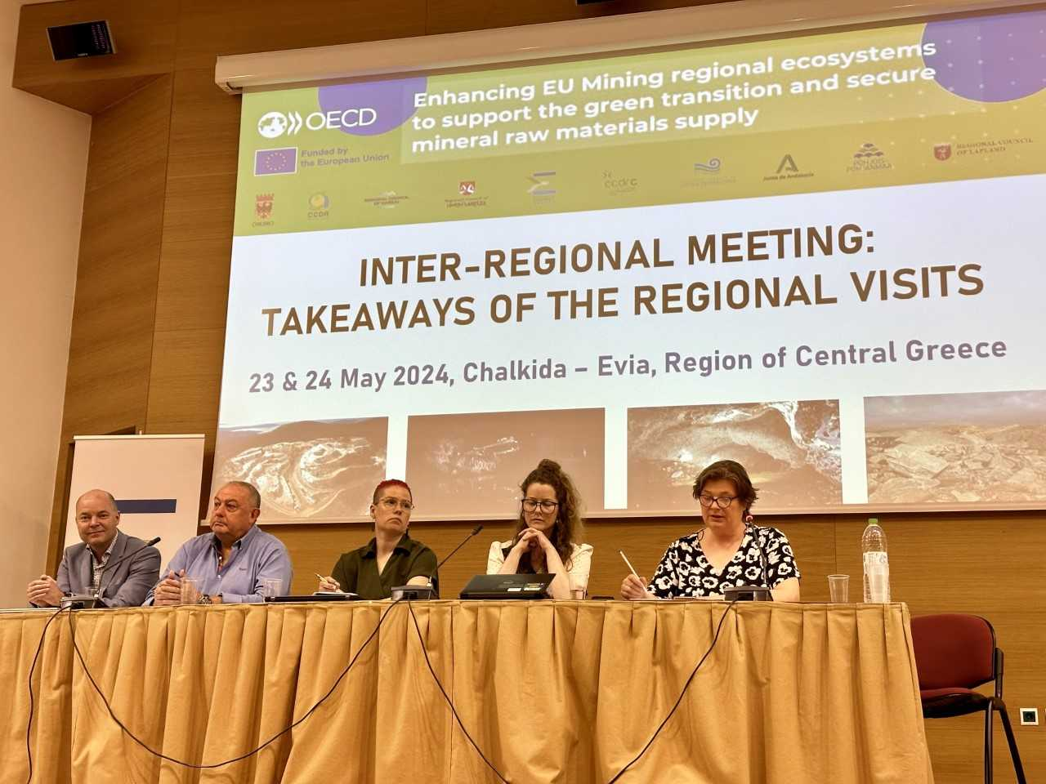
2nd Panel:
- Luis Martins, President for Associação Cluster Portugal Mineral Resources, representing Centro Portugal region.
- António Júlio Veiga Simão, senior adviser for the CCDRC Centro Portugal (virtual)
- Ida Paaso, Region of Lapland, Finland
- Jussi Ramet, Governor, Oulu Region
- Lotta Sartz, Region of Örebro, Sweden
- Kriistina Jokelainen, Representing Kainuu Region, Finland

Main messages:
- Municipal level governance is crucial for managing the impacts of mining, with alignment between municipal and regional authorities enhancing effectiveness.
- Innovation across the entire mining value chain is essential and presents an opportunity for regional economies to participate in sustainable mining practices.
- Effective communication between mining companies and communities is essential for ensuring mining activities are well-understood and supported by those directly affected.
- A monitoring committee is vital for overseeing the mining ecosystem, facilitating knowledge transfer and communication between stakeholders, and enhancing community engagement, with successful examples in Kainuu.
- Universities can play a crucial role in addressing social misconceptions around mining. This involves their contribution to a safe, sustainable, and flourishing mining sector as well as the dissemination of regular and transparent information to local communities.
- Policies need to integrate international cooperation and internal innovation, focusing on benefit sharing and worker upskilling to address local needs and enhance global competitiveness in the mining sector.

Good practices:
- Lapland: The municipality of Sodankula has been conducting informal gatherings between mining stakeholders and the local community to enhance company-community collaboration and increase social license to operate.
- Örebro: Northern municipalities where companies have active and long-term ESG programmes built through collaboration between companies and communities experience higher levels of social acceptance for mining projects. A mining company-led programme/fund to support local economic diversification is an example of this.
- Centro Portugal: The innovative research center at the Technological Centre for Ceramics and Glass has a dedicated sectoral center for innovation and advice, directed at local SMEs in the sector as well as the promotion of circular economy activities.

Afternoon session – breakout groups
Participants joined smaller groups to discuss issues of most relevance to regional mining ecosystems.

Group 1. Skills and talent attraction. Common priority actions include:
- Develop attractive policies and educational systems tailored to the mining sector's evolving needs.
- Enhance collaboration between companies, municipalities, and educational institutions to address skill shortages and training needs.
- Create supportive environments for international and regional workforce integration- e.g. International House Joensuu community-led language and cultural training such as in Sodankylä.
- Focus on strategies to attract and retain young people in the mining sector, learning from dual vocational programs (Finland) and ensuring comprehensive support systems
Group 2: Mining Governance and Planning. Common priority actions include:
- Regional mining or mineral related strategies are instrumental to guide priorities and calirfy the governemnt vision on how to link mining and regional development goals.
- Benefit sharing agreements with companies should be further explored to ensure a positive legacy of mining in the long-term regional development.
- A transparent fiscal system that ensures taxes from mining companies benefit hosting communities and those perceiving negative externalities is of relevance to ensure greater local well-being.
Group 3: Social perception and environmental considerations. Common priority actions include:
- School education programmes to raise awareness on the importance of minerals for everyday life and to address misinformation regarding mining is essential in improving social acceptance. Currently, mainstream education on mining is mostly related to negative environmental hazards. A balanced narrative is required.
- Increased company-community collaboration through information sessions, impact-benefit agreements, and strong ESG programmes are essential to increase trust and transparency for mining projects, which is currently lacking.
- Continious and transparent environmental monitoring is needed to address missconceptions about mining and mitigate negative environmental effects
Group 4: Innovation and circular economy. Common priority actions include:
- Integrating SMEs and entrepreneurs into circular economy and green mining innovation projects help ensure research materialises into local business opportunities.
- Regional governments can connect mining companies’ untapped opportunities on circularity with companies or researchers wiling to find bussiness solutions. Scale and distance to markets is a priority to address.
- Access to finance, incentives or grants to support bussiness for circular mining is needed to mitigate risks.
Next steps
- 2024 OECD Conference of Mining Regions and Cities to be hosted 8-11 October in Greater Sudbury, Canada. This Conference will be an opportunity to benchmark preliminary findings of this TSI project and share EU regions’ good practices for establishing mining ecosystems that benefit economic, social, and environmental wellbeing. Register for the conference here.
- In November, an inter-regional workshop in Bordeaux, France supported by TAIEX.
- Between January and February, 2025, a meeting in Brussels to align on final results and findings of the project.
- Launch of project in summer 2025 in Lapland, Finland.

