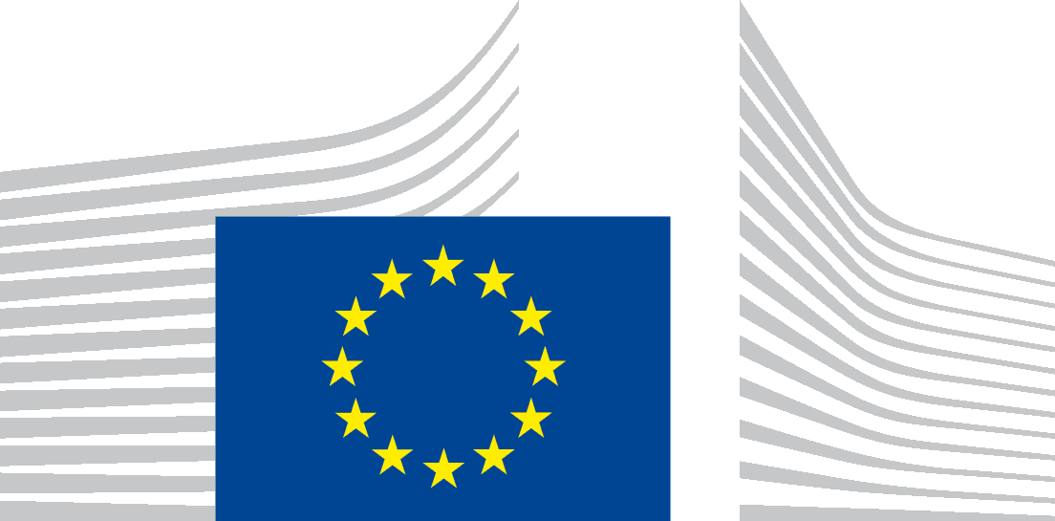 | EUROPEAN COMMISSION  DIRECTORATE-GENERAL FOR STRUCTURAL REFORM SUPPORT  Support to Member States Reforms  Governance & Public Administration

7th High-level meeting of the Expert Group on Public Administration and Governance
Malta, 15-16 May 2024
Minutes
On 15-16 May 2024, DG REFORM, Unit B2 - Governance and Public Administration, chaired the 7th High-level meeting of the Expert Group on Public Administration and Governance in Malta. The objectives of the meeting were to show case good practices where Malta and other Member State have a strong performance in the area of user-centric services (Day 1), to define the governance model for the ComPAct implementation plan and to map the preliminary needs of the Member States for the concrete implementation of flagship projects proposed for the 2025 TSI round (Day 2). 20 Member States were represented in person (40 participants approximately), 4 Member States were represented only online (44 persons approximately, including participants from services of the European Commission).
DAY 1
Mr Emanuel DARMANIN, CEO of the Malta Information Technology Agency (M.I.T.A.) opened Day 1 presenting the horizontal provision of digital services from M.I.T.A. to ministries and public entities in Malta while highlighting the efficiencies of scale achieved through the consolidation of digital governance into one service. Mr Mario NAVA, Director General of DG REFORM welcomed the participants and referred to the long way that we have covered since the first meeting of the Expert Group in 2021, the critical role of public administration in the new mandate of the Commission for the implementation of EU policies and the support that the Commission stands ready to provide through the Technical Support Instrument and ComPAct, incl. references to the new instrument on PEACE proposed in the Letta report.
Mr Massimo VELLA, CEO of Servizz.gov focused on success factors for delivering services to citizens in Malta. His presentation emphasised the provision of user-centric services with Malta showcasing impressive achievements through their portal "Servizz.gov". Malta already offers more than 1600 key public services online, with the ultimate objective to meet the EU requirement for having all key public services available online by 2030. Guidance is provided to authenticated, but also to anonymous users who do not want their questions/information to be used by the administration. This feature contributes to increased trust of citizens in the administration. Prof. Vince CASSAR highlighted the aspects of evidence-informed decision making towards citizens satisfaction based on the feedback received by the users of public services.
A session including good practices from Member States in the area of user-centric services followed. Ms Vivi CHARALAMBOYIANNI, Deputy Minister of Interior of Greece and Mr Fotios BENEKOS, key expert of Expertise France presented how they mobilise Artificial Intelligence (AI) to help more than 100 000 public entities set goals which are meaningful and SMART. Upon completion of the project, the Greek authorities will have at their disposal a full-fledge Digital Goal Assistant which will help ensure that the individual goals are SMART and in line with Government policy. Ms Marianne CASSIDY, Assistant Secretary, Public Service Transformation Division from Ireland presented evidence informed policies and services design for and with people. The aim is to create a fully Digital Government which is open and with a user driven, design led public service transformation focusing on outcomes which are relevant for their citizens/businesses. Mr Thomas GIACOLETTO, DG REFORM presented interoperability requirements for the provision of proactive public services and the importance of having a whole-of-government approach when designing the work processes. Proactive services include the provision of services by the Government automatically as soon as citizens fulfil the statutory eligibility criteria without submitting prior applications (e.g. receiving a pension when the pension age is reached).
In the afternoon, an on-site visit to the Public Service Expo was organized in the context of the week of public administration in Malta, which show cases the public administration to the general public and students. The European Commission representatives and the members of the Expert Group were welcomed by the Principal Permanent Secretary and the Permanent Secretaries representing all Ministries within the Maltese Public Administration. The visit also included a guided experience of the various Ministries’ stands.
DAY 2
Mr Kjartan BJÖRNSSON, Deputy Director and Head of Unit B.2 opened the discussions of Day 2 thanking the speakers of Day 1, especially the Maltese representatives with reference to the 20th anniversary of Malta after its accession to the EU. He referred to the challenges in the provision of user-centric services (GDPR, interoperability, etc.) and the need to work together within the Single market for achieving Europe’s competitiveness. Public administrations have an important role to play in this respect, as recognised in the Letta report. Moreover, ComPAct is a comprehensive set of support measures available to the Member States for addressing common challenges.
Ms Joyce CASSAR, Permanent Secretary, People & Standards of the Office of the Prime Minister of Malta welcomed the participants and referred to the common challenges that public administrations face in Europe with focus on the lack of attractiveness in public administration. She presented the basic principles of strategies for attracting and retaining talents with the participation of academics.
During the second session, Mr BJÖRNSSON gave an overview of the feedback received by the Member States on the ComPAct implementation plan as incorporated in the update plan. He focused on the overall positive feedback received, the voluntary nature of ComPAct actions, the link between ComPAct and the TSI, the priorities of the Member States, the interconnections amongst the 3 pillars and the cross-cutting role of the regional and local authorities. DG REFORM has made considerable efforts in incorporating the comments from EU Member States and has worked with other Commission services to ensure that the most relevant priorities will be implemented in a consistent and cost-efficient manner. The revised version of the ComPAct implementation plan now links better the three pillars and introduces a clearer timeline and stakeholders’ involvement. Many of the actions will be linked to TSI, that will remain the key instrument, and the Committee of the Regions can be included as an observer of the Expert Group. Implementation has already started (58 activities planned for this year), some of them with REFORM on the lead in collaboration with other DGs. Mr BJÖRNSSON informed the Expert Group of the ComPAct conference (see below) on 27/6 which will be combined with a technical meeting of the Expert Group on 26/6.
Ms Athina MANTA, Policy Officer, DG REFORM presented the proposed governance structure of ComPAct with the Expert Group. The Expert Group will retain the steering role for the implementation of ComPAct and will be kept informed at regular intervals. In parallel, DG REFORM will leverage knowledge for the design of specialised ComPAct activities from other networks, including Commission specialised Expert Groups and DISPA for avoiding duplication of work. Ms Mina SHOYLEKOVA, Head of Sector for public administration and governance, DG REFORM explained the actions related to the flagship projects for 2025, giving an overview of the ones to be launched in 2024, as well as the actions for which interest has already been demonstrated (e.g. Network of Centres of Excellence, the Passport of core competences for Pillar I; the roadshows for interoperability, for Pillar 2; and the EU green procurement helpdesk for Pillar III). The ComPAct implementation plan is ambitious but realistic. DG REFORM will design a convincing monitoring tool, which will keep track of each of the actions/activities in the implementation plan but also visualise how we are progressing overall in terms of enhancing the European Administrative Space. This will be complemented by stories on each reform initiative or cluster of initiatives demonstrating the concrete impact of our joint work on public administration and ComPAct.
A session including questions and answers followed where several Member States took the floor (NL, FR, DE, PT, ES, IT, HU, LV, IE, RO, ML and EL). Main topics included:
- Several Member States expressed their satisfaction for the consideration of their comments reflected in the revised ComPAct action plan.
- The role of the Expert Group vis-à-vis other networks (EUPAN, DISPA) and national institutions (with specialised competence on Pillars II and III) was discussed. Member States explained that they lack the capacity and the mandate for steering implementation at national level including coordination with other Commission networks. DG REFORM replied that the oversight role of the Expert Group will be vis-à-vis DG REFORM who will be responsible for the coordination with other networks, for keeping track and monitoring implementation and for updating the Expert Group on the progress. DG REFORM will elaborate and soon share a concrete proposal on the Governance structure of ComPAct in written. Member States will have no reporting obligations.
- Representatives from National Schools of Public Administration proposed that their DISPA members work on specialised actions of Pillar I (networks of Centres of Excellence, passport of core competences and the leadership programmes) in a distinct way from the Expert Group. DG REFORM took note of the comment and will consider it in the governance structure (see above).
- The added value of the Expert Group was highlighted for the exchange of good practices and the bottom-up approach for the feedback on the TSI requests. For Pillar II, existing tracking tools could be used for monitoring progress.
- Cross-country collaboration was supported and it was proposed the action plan focus on cooperation rather than measurement and metrics. DG REFORM took note of the comment and the tracking and monitoring tool to be made public will enable the Expert Group members to oversee progress and seek collaboration at their pace.
- at EUPAN and the Expert Group remain complementary. DG REFORM explained that the two networks have different mandates, while stressing the need for communication between the two.
- Some concerns were expressed on the differences of management of TSI projects in other Member States DG REFORM explained that the requests are prioritised by the Coordinating Authorities but the Commission applies the TSI Regulation criteria for the selection of mature and impactful projects.
In the penultimate session, DG REFORM (Mina SHOYLEKOVA, Thomas GIACOLETTO, Athina MANTA) presented the 2025 flagship projects linked to Public Administration and Governance, namely on "Skills for public administration systems", "Capacity for Europe's Digital Decade", "Greening Public Administration" and "PACE - Public Administration Cooperation Exchange". On this basis, DG REFORM organised a discussion with EU Member States on which specific problems they would like to cover under these flagships either alone or as a multi-country project. The initial discussion focused on the creation of EU-wallets, PACE and citizen's participation, attractiveness of public administration, but there were also suggestions for looking into common constraints from GDPR rules for the provision of pro-active provision of public services.
Finally, Ms SHOYLEKOVA presented three specific TSI projects related to evidence informed change management.
Mr BJÖRNSSON closed the meeting by thanking the Maltese authorities, his team, and all the participants for engaging in meaningful discussions and highlighted the importance of sharing good practices and information among Member States, especially those which can be replicated for addressing similar challenges.
The next meeting will take place in-person in Brussels on 26 June 2024. It will focus on the progress of the ComPAct implementation plan, the toolkit on the quality of public administration and the tracking mechanism to measure progress of ComPAct. It will be combined with the Conference on ComPAct High-level conference: “A growth enhancing public administrative space” - European Commission (europa.eu) on 27 June.

Enhancing the European Administrative Space (ComPAct) - European Commission (europa.eu).
Enrico Letta - Much more than a market (April 2024) (europa.eu)

