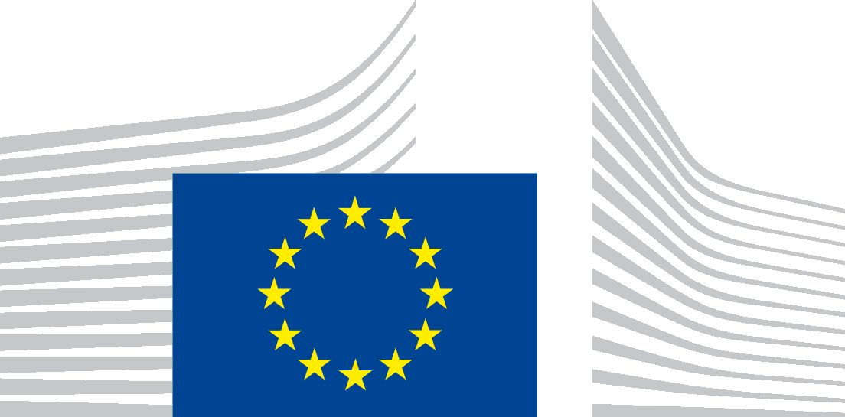
TECHNICAL SUPPORT INSTRUMENT (TSI) PROGRAMME
DG REFORM LIST OF TOPICS
- Accrual accounting  - Access to finance  - Administrative cooperation and exchange of information in taxation  - Aggressive tax planning, Base erosion and profit shifting (BEPS) and transfer pricing  - Air quality, pollution prevention and control  - Anti-corruption/anti-money-laundering  - Bank supervision and resolution  - Better regulation, licensing, inspections and market surveillance  - Biodiversity, forestry and agriculture  - Budget preparation and implementation  - Capital Markets Union  - Central and local administration  - Circular economy  - Civil protection and natural disasters  - Climate change adaptation  - Climate change mitigation  - Climate and energy planning and modelling  - Competition and consumer policy  - Competitiveness  - Crisis management  - Customs administration  - Debt and cash management  - Defence  - Digital/Information Communications Technology (ICT)  - Digital economy  - Digital finance  - Digital Public Administration  - Digital Transformation of Tax and Customs Administrations  - Digitalisation of revenue administration  - Directive on Administrative Cooperation (DAC)  - Do No Significant Harm (DNSH) principle  - Education and vocational training  - Enhancing the Quality of Public Finances  - Energy efficiency  - Energy markets  - Environmental enforcement  - Environmental taxation  - Environment and Safety  - Equality  - EUROMOD  - Expenditure policy  - Fight against aggressive tax planning, tax fraud and evasion  - Financial literacy  - Fiscal Decentralisation/Devolution  - Fiscal strategies and tax policy  - Foreign investments and trade  - Gender mainstreaming in public policy and budget processes  - General Recovery and Resilience Plan (RRP)  - Governance  - Green budgeting  - Green modelling  - Green taxation  - Health | - Healthcare system  - Hydrogen  - Industry and industrial ecosystems  - Insolvency  - Insurance and pensions  - Judicial reform  - Just Transition  - Labour market and employment  - Land registry and spatial planning  - Macro-fiscal framework  - Management of EU funds  - Management of human resources  - Medium term budgetary framework  - Migration and border management  - Modelling, analysis and assessments  - Modelling Macro/fiscal  - Modelling Micro/fiscal  - Non-performing loans  - Payments  - Performance Budgeting  - Productivity, competitiveness and growth strategies  - Public sector accounting  - Public sector statistics  - Public finances oversight  - Public Investment Management  - Public Private Partnerships (PPPs)  - Public procurement  - Renewable energy  - Research and innovation  - Revenue administration and customs  - Sanctions  - Services and Sectors  - Small and medium-sized enterprise (SME) and entrepreneurship  - Social protection and social services  - Space  - Spending reviews  - State-owned enterprises (SOEs), state assets  - Sustainable Finance  - Sustainable development and Sustainable Development Goals (SDGs)  - Sustainable Growth & Business Environment  - Sustainability  - Social Policies  - Tax compliance strategies and approaches  - Tax administration  - Tax evasion and tax fraud  - Tax gaps  - Tax policy and legislation assessments  - Tourism & creative industries  - Transport and mobility  - Waste, waste water and marine resources  - Welfare system  - Youth, Sport and Culture  - Other

CURRENT
- Accrual accounting
- Access to finance
- Administrative cooperation and exchange of information in taxation
- Aggressive tax planning, Base erosion and profit shifting (BEPS) and transfer pricing
- Air quality, pollution prevention and control
- Anti-corruption/anti-money-laundering
- Bank supervision and resolution
- Better regulation, licensing, inspections and market surveillance
- Biodiversity, forestry and agriculture
- Budget preparation and implementation
- Capital Markets Union
- Central and local administration
- Circular economy
- Civil protection and natural disasters
- Climate change adaptation
- Climate change mitigation
- Climate and energy planning and modelling
- Competition and consumer policy
- Competitiveness
- Crisis management
- Customs administration
- Debt and cash management
- Defence
- Digital/Information Communications Technology (ICT)
- Digital economy
- Digital finance
- Digital Public Administration
- Digital Transformation of Tax and Customs Administrations
- Digitalisation of revenue administration
- Directive on Administrative Cooperation (DAC)
- Do No Significant Harm (DNSH) principle
- Education and vocational training
- Enhancing the Quality of Public Finances
- Energy efficiency
- Energy markets
- Environmental enforcement
- Environmental taxation
- Environment and Safety
- Equality
- EUROMOD
- Expenditure policy
- Fight against aggressive tax planning, tax fraud and evasion
- Financial literacy
- Fiscal Decentralisation/Devolution
- Fiscal strategies and tax policy
- Foreign investments and trade
- Gender mainstreaming in public policy and budget processes
- General Recovery and Resilience Plan (RRP)
- Governance
- Green budgeting
- Green modelling
- Green taxation
- Health
- Healthcare system
- Hydrogen
- Industry and industrial ecosystems
- Insolvency
- Insurance and pensions
- Judicial reform
- Just Transition
- Labour market and employment
- Land registry and spatial planning
- Macro-fiscal framework
- Management of EU funds
- Management of human resources
- Medium term budgetary framework
- Migration and border management
- Modelling, analysis and assessments
- Modelling Macro/fiscal
- Modelling Micro/fiscal
- Non-performing loans
- Payments
- Performance Budgeting
- Productivity, competitiveness and growth strategies
- Public sector accounting
- Public sector statistics
- Public finances oversight
- Public Investment Management
- Public Private Partnerships (PPPs)
- Public procurement
- Renewable energy
- Research and innovation
- Revenue administration and customs
- Sanctions
- Services and Sectors
- Small and medium-sized enterprise (SME) and entrepreneurship
- Social protection and social services
- Space
- Spending reviews
- State-owned enterprises (SOEs), state assets
- Sustainable Finance
- Sustainable development and Sustainable Development Goals (SDGs)
- Sustainable Growth & Business Environment
- Sustainability
- Social Policies
- Tax compliance strategies and approaches
- Tax administration
- Tax evasion and tax fraud
- Tax gaps
- Tax policy and legislation assessments
- Tourism & creative industries
- Transport and mobility
- Waste, waste water and marine resources
- Welfare system
- Youth, Sport and Culture
- Other

