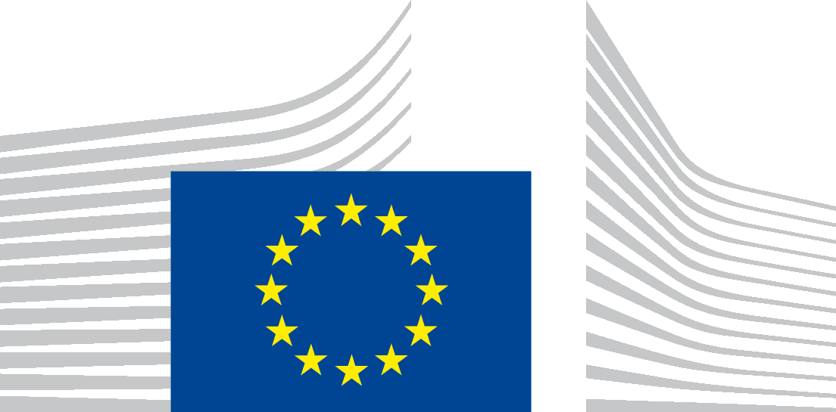 | EUROPEAN COMMISSION  DIRECTORATE-GENERAL FOR STRUCTURAL REFORM SUPPORT  Support to Member States Reforms  Governance & Public Administration

6th High-level meeting of the Expert Group on Public Administration and Governance
Brussels, 18-19 January 2024
Minutes
On 18-19 January 2024, DG REFORM, Unit B2 - Governance and Public Administration, held the 6th High-level meeting of the Expert Group on Public Administration and Governance. The objective of the meeting was to discuss the most relevant actions of the recently published Communication of the European Commission on Enhancing the European Administrative Space (ComPAct) - European Commission (europa.eu) for Member States from the perspective of their national priorities and defining the modalities of implementation.
Mario NAVA, Director General, DG REFORM welcomed the participants and explained that the aim of the meeting was to discuss the overall policy context for the three pillars of the ComPAct (Skills, Digital and Green) with relevant services responsible for Reforms, Single Market, Digitalisation, Environment, Climate and Joint Research in order to pave the way for the elaboration of a ComPAct Action Plan.
An exchange with Directors Nathalie BERGER, DG REFORM, Mary-Veronica TOVSAK PLETERSKI, DG GROW, Natalia ARISTIMUNO PEREZ, DG DIGIT, Paul SPEIGHT, DG ENV and Jolita BUTKEVICIENE, JRC set the policy context related to the actions of ComPAct and underlined the relevance of public administrations for the smooth functioning of the Single Market, the need for an exchange at all levels of governance and cross-border collaboration to facilitate the digital transition, the importance of developing new skills for greening the public administration and the importance of innovation and capacity-building for public administrations for addressing the challenges of the future.
Athina MANTA, Policy Officer, DG REFORM, presented a summary of a survey on Member States’ priorities related to the ComPAct actions. The survey revealed that national reform priorities focus on civil service issues (skills, recruitment, attractiveness, training), quality and accessibility of public services for the digitalisation agenda.
Kjartan BJÖRNSSON, Deputy Director and Head of Unit, DG REFORM, presented the overview of the multi-country projects, the areas of reforms for the pre-selected reform projects under the TSI 2024 cycle and the next steps underlining in particular the need to ensure that the ComPAct actions would yield concrete benefits for the Member States.
Alexandra PAPATHEODOROU, Policy Officer, DG REFORM, introduced the presentation of the study on “The Cost of Underperformance in Public Administration”, by Steven VAN DE WALLE (KU Leuven) and Anthony BARKER (Cambridge Econometrics), which triggered reactions from some Member States who cautioned that our focus should not be limited to the potential for cost reductions but cover the important aspect of securing high quality services for citizens. This was followed by presentation on the history and prospects of EU support to Public Administrations’ reforms by Professor Edoardo ONGARO.
Dedicated sessions amongst Commission officials and representatives of the Member States on specific actions of ComPAct followed during the first and the second day that can be summarised as follows:
• For Pillar I (skills), national reform priorities covered civil service skills, recruitment, attractiveness and training. Quality and accessibility of public services were also highlighted as essential for the digitalisation agenda. The ComPAct actions “Passport of core competencies” and “EU Leadership programme” were mentioned as specific national reform priorities. PACE remains a key priority and Member States presented suggestions for improving its efficiency and visibility.
• For Pillar II (digital transition of public administrations), the need for a whole-of-government approach was underlined. The priority topics include sharing of good practices, focusing on the user-friendliness and accessibility of (digital) public services, creating common requirements for the procurement of cloud services to increase government negotiating position with providers, understanding the impact of AI on public administrations.
• For Pillar III (Capacity to lead the green transition), the input from the Expert Group was more limited and require further work from the Commission. The Expert Group members wanted more guidance on how green governance will build on existing efforts linked to climate adaptation and green procurement. Members wanted support on defining “green skills” and indicated interest in a potential TSI multicounty project on greening of public administration.
On the second day, a successful PACE project between DK and NL administration was presented by Maria Møller KURSCH, International Coordinator, Danish Agency for Public Finance and Management, showing the importance of the preparation phase as key element of success: taking time to know your working partners and the common ground to be established before starting the exchange.
Peter BASTIAENS, Senior Advisor, Federal Public Service Policy and Support (BOSA), explained the priorities of the BE Presidency for the next 6 months, mainly on HR transformation, green public services and organisational changes and public transformation, serving the twin transitions.
Finally, Kjartan BJÖRNSSON thanked the audience and the different speakers, and announced that building on the input from the detailed discussion on the various priority actions, DG REFORM will work, together with other Commission services and the Member States, to create a detailed action plan of the ComPAct, including the specific actions to be prioritised, their implementation and their timeline.
The next meeting of the Expert Group on Public Administration and Governance will take place online in March, and the next in-person meeting on 16-17 May in Malta (tbc).

