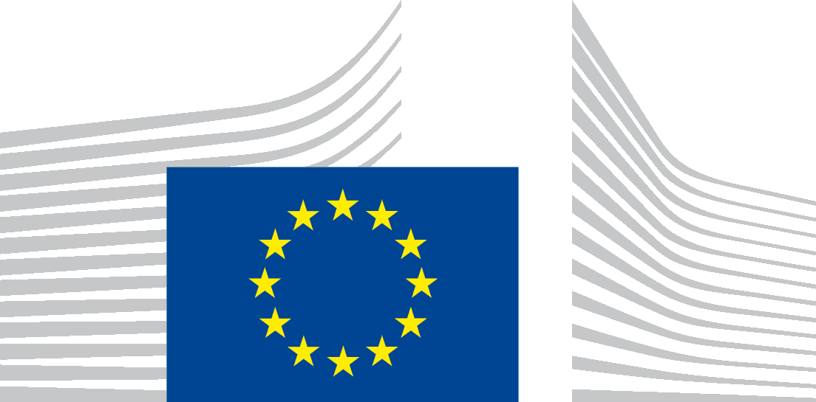 | EUROPEAN COMMISSION  DIRECTORATE-GENERAL FOR STRUCTURAL REFORM SUPPORT  Support to Member States Reforms  Governance & Public Administration

Technical meeting of the Expert Group on Public Administration and Governance
Brussels, 26 June 2024
Minutes
On 26 June 2024, DG REFORM, Unit B2 - Governance and Public Administration, chaired a technical meeting of the Expert Group on Public Administration and Governance in Brussels. The objectives of the meeting were to update the participants on the ComPAct implementation plan, to present its draft monitoring mechanism and to inform them on the online Toolbox on Quality of Public Administration. The participants in the meeting were also invited to attend the ComPAct Conference on 27 June.
15 Member States and 5 observers including Expertise France (EF), the European Federation of Public Service Unions (EPSU), the Committee of the Regions (CoR), the European Public Law Organization (EPLO), the European Institute of Public Administration (EIPA), were represented in person (28 participants), while 12 Member States were represented online (33 persons approximately, including participants from services of the European Commission and other observers).
Ms Nathalie BERGER Director of DG REFORM opened the meeting explaining the critical role that the public administration will play for competitiveness and the completion of the Single Market. She noted that while the priorities of the new Commission are still to be announced, it is expected that there will be an emphasis on implementation of the new EU legislation. She referred to the European Semester Spring package and public administration issues that it reflects ranging from aging to absorption of the funds of the Recovery and Resilience Facility. The TSI and ComPAct can be used for addressing the challenges that the Member States are facing.
An overview of the progress achieved on the ComPAct implementation plan was presented by Mr Kjartan BJÖRNSSON, Deputy Director and Head of Unit B.2, including the leveraging role of other networks such as existing expert groups of the European Commission, the creation of specialised working groups for creating content on the centres of excellence and leadership programme, the positive opinion of the Committee of the Regions and the role of the TSI flagship projects in line with the three pillars of ComPAct. The issue of transparent monitoring of ComPAct’s implementation was covered by Mr Thomas GIACOLETTO, DG REFORM, who gave the overview of the monitoring mechanism and the tool designed to follow the progress achieved. The tool will be used to facilitate not only the monitoring of the progress (by tasks and by pillars) but also to get general information of ComPAct and how to get involved in its implementation. Progress will be reported to the Expert Group on Public Administration and Governance three times a year; and the inclusion of outcome indicators will be explored.
Observers intervened to explain how they can support the implementation of ComPAct based on their expertise and stressed the importance of including local and regional authorities in technical support projects and in the implementation of ComPAct, especially in relation to interoperability, and the need to reflect on the social aspects of ComPAct and its links with EU Social Directives, the use of public procurement for promoting the green transition.
Constructive discussions with the representatives of the Member States focused on the synergies needed for ComPAct’s implementation, the cooperation amongst the Member States for certain popular activities, the measurement of results and the upscaling of PACE, including its evaluation and the setup of a technical group on PACE. As regards the monitoring tool, it was suggested to include contact points and dates, the improvement of the numbering of ComPAct activities, as well as the provision of links to TSI (past and current) projects and further information. A clarification on the quantification of the percentage related to the progress was also provided. Also, there were comments on the status of the progress of some activities that will be reflected in a later version of the implementation plan.
Mr. Peter BASTIAENS, Senior Advisor (Belgium) shared the conclusions of the BE EU Presidency, including, specific achievements covering the Ghent Declaration with a focus on evidence-informed policy making, the need to measure training impact and the current debate around capacitating public administration with in-house consulting and the use of technology and AI as a means to an end. Highlights include the presentation of the first edition of the HR scorecard (with valuable HR data from all Member States), shared opinions on strengthened European collaboration for the identification of benchmarks and the willingness of the Member States to use EU instruments such as PACE, ComPAct, TSI and the interest of third countries to join the EUPAN network.
Mr. Gergő SZIMA, Head of the Department for Legal and International Affairs of Government (Hungary) presented institutional changes of the public administration centralising in one service the territorial competences, the local government and the regional development, and the main priorities of the upcoming EU presidency in the Council and in the EUPAN. Priorities include the focus on the adoption of new European Competitiveness Agreement, the strengthening of the European Defence Policy, the enlargement policy, the farmer-centred agricultural policy and sustainability fisheries, the future of the cohesion policy, management of demographic challenges and illegal migration. In the area of public administration and government decision-making support, demographics and their impact on HR policies will be at the forefront in combination with digital transition and the greening of public administration.
Finally, Ms Mina SHOYLEKOVA, DG REFORM presented the highlights of the revision of the online Toolbox on Quality of Public Administration (Publications catalogue - European Commission) combining theory, practice and case studies and good practices from the Member States. The online toolbox is aiming to be a user-friendly tool. It will continue to cover areas ranging from policymaking to business environment and effective justice systems and add new aspects as becoming a digital administration and green governance. The Toolbox can be used by Member States for inspiration and orientation, to promote dialogue and exchange among each other. Positive reactions from the Member States demonstrated the need to revisit the toolbox as a valuable resource and expand on topics, for example leadership. A close collaboration with Member States can help promote further positive examples, such as AI, and to make the content available in different languages. Member States welcomed the possibility to have online trainings and to link the tool with TSI projects and other DGs initiatives. Collective ethos promoted by trade unions, human centric services, and other social issues (equality, diversity, inclusion) would be essential elements to reflect in the future, as they have an impact on the quality of public administration. There were also questions about how the toolbox will be updated and how to participate in the trainings, as well as a clarification on how the case studies were selected, with a focus on the old practices.
Mr BJÖRNSSON closed the meeting by thanking his team and all the participants (members of the EG and observers) for their interest on the progress on ComPAct and reassuring the Commission willingness to do more to ensure the correct implementation of the communication and the inclusion of further outcome indicators.
The next meeting will take place in-person in Ispra, Italy, most probably in the period from end September – early November.

