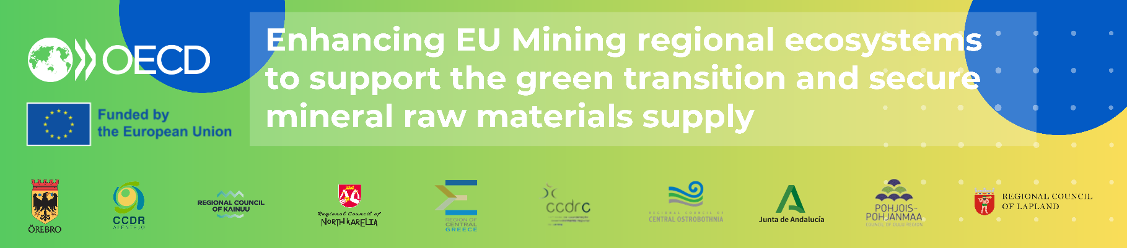

Takeaways of the OECD mission to Orebro, Sweden
TSI OECD-DG REFORM project – April 22 to 25

Introduction
The OECD study mission to Orebro region, Sweden took place from 22 to 25 April 2024. This visit allowed for a series of discussions in five municipalities, including the capital of the region, with diverse regional stakeholders ranging from regional to municipal government representatives, universities, and the private sector. The peer reviewers included three representatives from North Karelia region: Maarit Siitonen (Regional Council of North Karelia), Asse Marjasvaara (GTK Mintec), Ilkka Nykanen (Business Joensuu, Business Development Agency).
Current state
The region has a significant mining history dating back to the 13th century with the first Iron mines in the country. Today, the region has two active mines and several closed mines (rehabilitated or remediated), with some of them being potential source of critical minerals. The region is a well-connected area, just two hours from Stockholm, with a vibrant University with high-tech focus and hosting one of the largest producers of mining equipment in the world- Eprioc.
Örebro’s mining ecosystem contributes significantly to the local economy as well as to national and global mining innovation activities. The two operating mines in the region employ about 700 people combined. The Lovisa mine, first established in 1993, extracts lead, silver, and zinc, while the Zinkgruvan mine, first established in 1700, extracts 1 lead, zinc, and copper entirely underground since 2022. The Swedish mining equipment company Epiroc employs over 2800 people and plans to establish an underground mine for a test centre, in collaboration with industry and academia.
Strengths | Bottlenecks
Enabling transport and energy infrastructure: expected high-speed train to Oslo enhances connectivity with other regions and municipalities. | Lengthy and expensive permitting process hinders new investments and complicates current operations, specially of small mines.
Innovation hub with potential for mining, featuring a mining equipment company Epiroc and a university with expertise in innovation. | Unclear regional strategy and vision for the role of mining for the regional development and low level of integration of municipal governments in potential mining projects.
Longstanding successful mining operations such as Zinkgruvan mine, contributing significantly to local development. | Rising energy costs make mining operations costly and deter new companies from entering the market

Key Takeaways
Mining Governance and environmental considerations
- There is a need to clarify the regional strategic vision for leveraging current and future mining projects, as well as related businesses, to drive regional development.
- There are no clear strategies to analyse business opportunities in reusing or remining old mine sites. Management of old mines in the region has focused on rehabilitation and remediation.
- Municipalities need to be better involved in exploration prospects and potential mining projects in their areas to allow them for better planning for synergies with the municipal development strategies. Given that mining exploration is decided and guided at the national level, a bridge to connect local priorities with national goal is needed.
- Old tailings pose uncertain environmental and urban development impacts in certain municipalities. For example, they affect environmental permitting for housing construction in Ljusnarsberg and near the golf course in Askersund.
Employment and skills
- Vocational education for mining is scarce, as are dual programs transitioning from vocational to professional education. The Bergsskolan technical school in nearby Filipstad exemplifies vocational education tailored to industry needs.
- There is scope to better connect the university of Orebro, whose core education areas with links to mining include AI& Robotics and Pollutants, and that of the needs of the regional industry, including metallurgy and mining operations that lack educated and experienced professionals.
Innovation and circular economy
- The region can leverage its innovation ecosystem to benefit from local and national mining developments. This involves better connecting Örebro University’s innovation in digitalization and AI capacities with Epiroc’s technology leadership and entrepreneurs seeking opportunities, for example through an innovation platform.
- There is scope to leverage EU and national innovation funds to support activities with old mines and with a high-tech mining equipment and services.
Good practices:
ESG and Responsible mining
- The diversification fund of Zinkgruvan is a leading practice to promote local growth beyond mining. It is co-managed with the municipal government to provide fund mentorship, business planning, and training for entrepreneurs and companies in the region. Forty companies have benefited from the program, which proved particularly valuable during the pandemic.
Governance and Innovation ecosystem
- The regional government is tapping into the University to advance the mining related policy in the region. This is a good basis for more formal collaboration to support regional policy and business ecosystem.
- The recently created Business Region Orebro and the Industrial Hub are useful platforms to connect mining companies, providers, and research centers to address main priorities of the sector for the development of the region. It is a good basis that need further presence outside Orebro to connect rural business/entrepreneurs.
- REEDEAM project, funded by the KK-Stiftelsen (Knowledge Foundation), where three universities in Örebro, Västerås and Luleå work together with industry to create courses for professionals on advanced level to support the green transition.
- The EU-funded FutuRaM project aims to improve knowledge and data about recoverability and availability of minerals with a reporting structure, guidelines for raw materials’ use and a standard method to identify mining waste.

